Jose Amador

Cameron Mastoras

ME 340-2 UA Notes

So you have signed up to be the UA for ME 340-2. Well good news for you is that a lot of the work has been done already and you just need to get the setup done and cut/machine all the blanks. When reading this if you have any questions or concerns feel free to text me or email me @ (408) 910-2845 or joseamador2022@u.northwestern.edu.

The programs are set up very elegantly (thank you George) and use two vices and coordinate systems, G54 and G55. The setup is shown below in Figure 1. There are just two programs, one for the core and one for the cavity. Each program uses the same two coordinate systems and the same tools so you can easily switch between them after putting in the proper materials

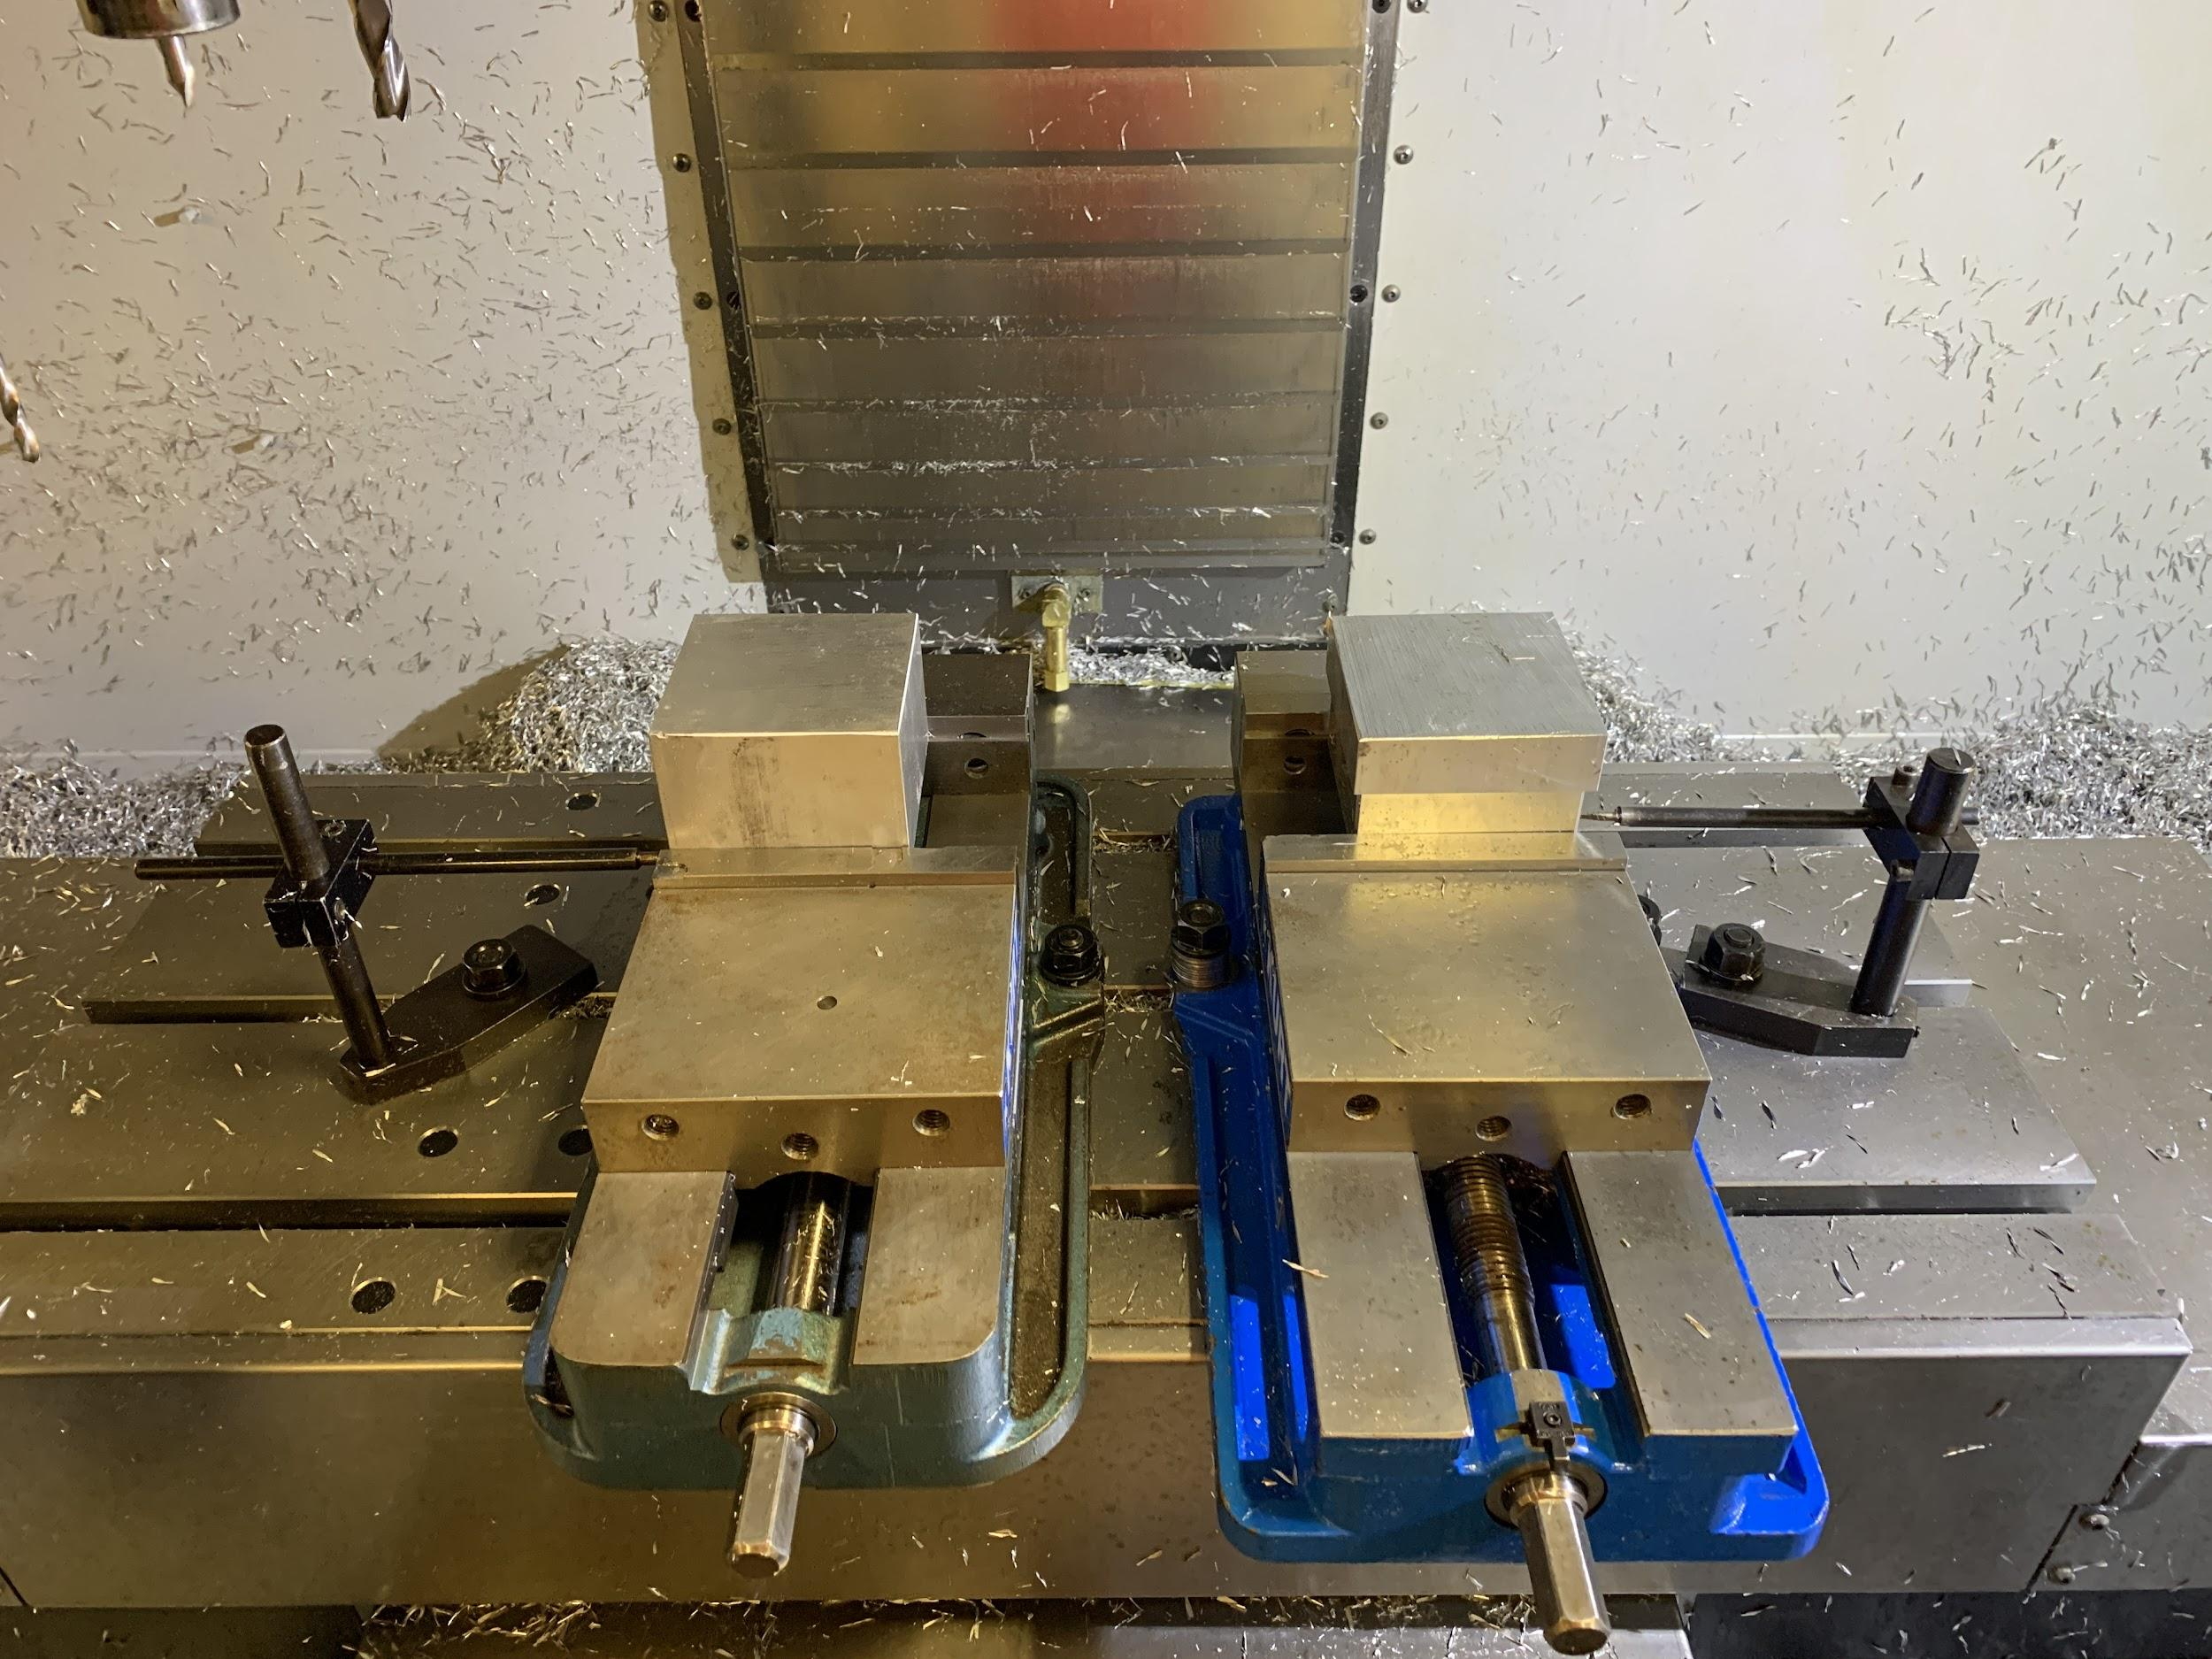

Figure 1: Vice Setup

G54

G54 is the left vice and machines a completely rough blank. When the program runs it will machine half of the blank. This half-completed blank should be moved to the right vice and a new completely rough blank should be placed in the left vice.

The XY zero is set on a corner on the left (double check the programs for specifics) and the block is set up against a stopper that sits below the top of the vice so it does not get machined as shown below in Figure 2.

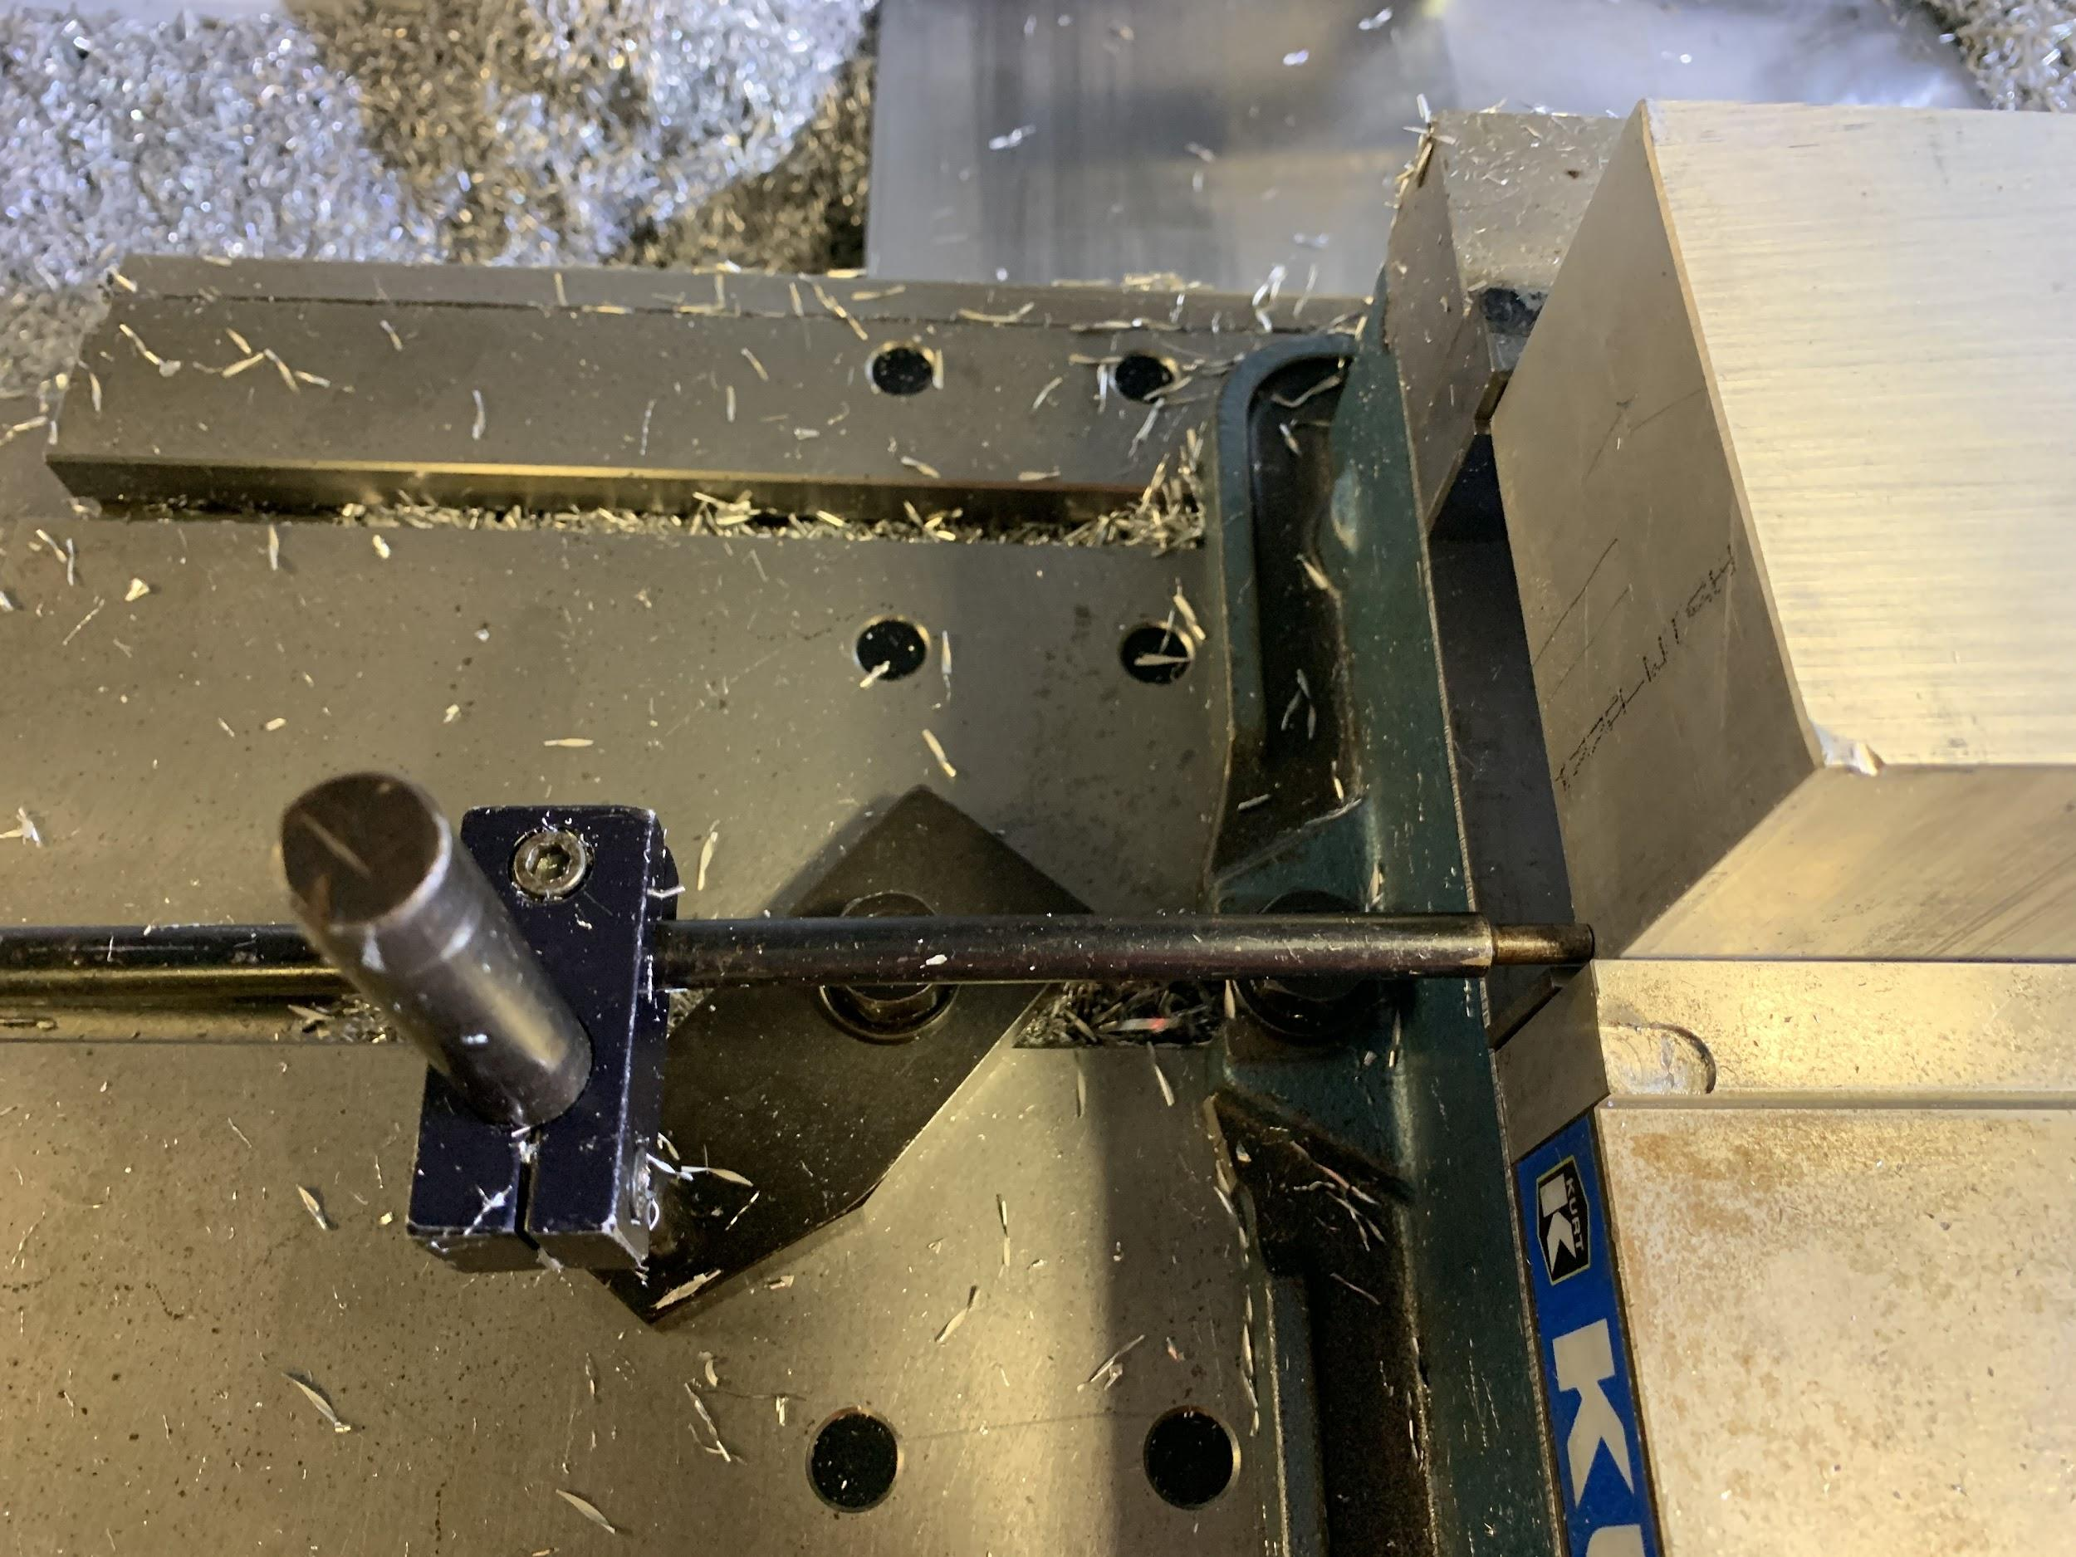.

Figure 2: G54 Stopper

G55

G55 is the right vice and machines a blank that is half completed (taken from the left vice). When placing a blank in this vice PAY ATTENTION TO THE ORIENTATION so that way it is machined properly. There is one corner that is rounded and that corner should be in the top left. Furthermore, the precision placement of this block will determine how aligned the two faces of the block are. The G55 x-coordinate zero was slightly adjusted to dial this in, however it still wasn't very precise.

The XY zero is set on a machined surface that you can't directly edge find off of (because the blank is not done yet). You can pick up the y-zero by using the stationary vice jaw. You can pick up the x-zero by setting up the stopper and using some flat piece of metal that is against the stopper (which is exactly where the blank sits).

The stopper once again sits below the top of the vice so it does not get machined, however now it goes up against a precision machined surface as shown below in Figure 3.

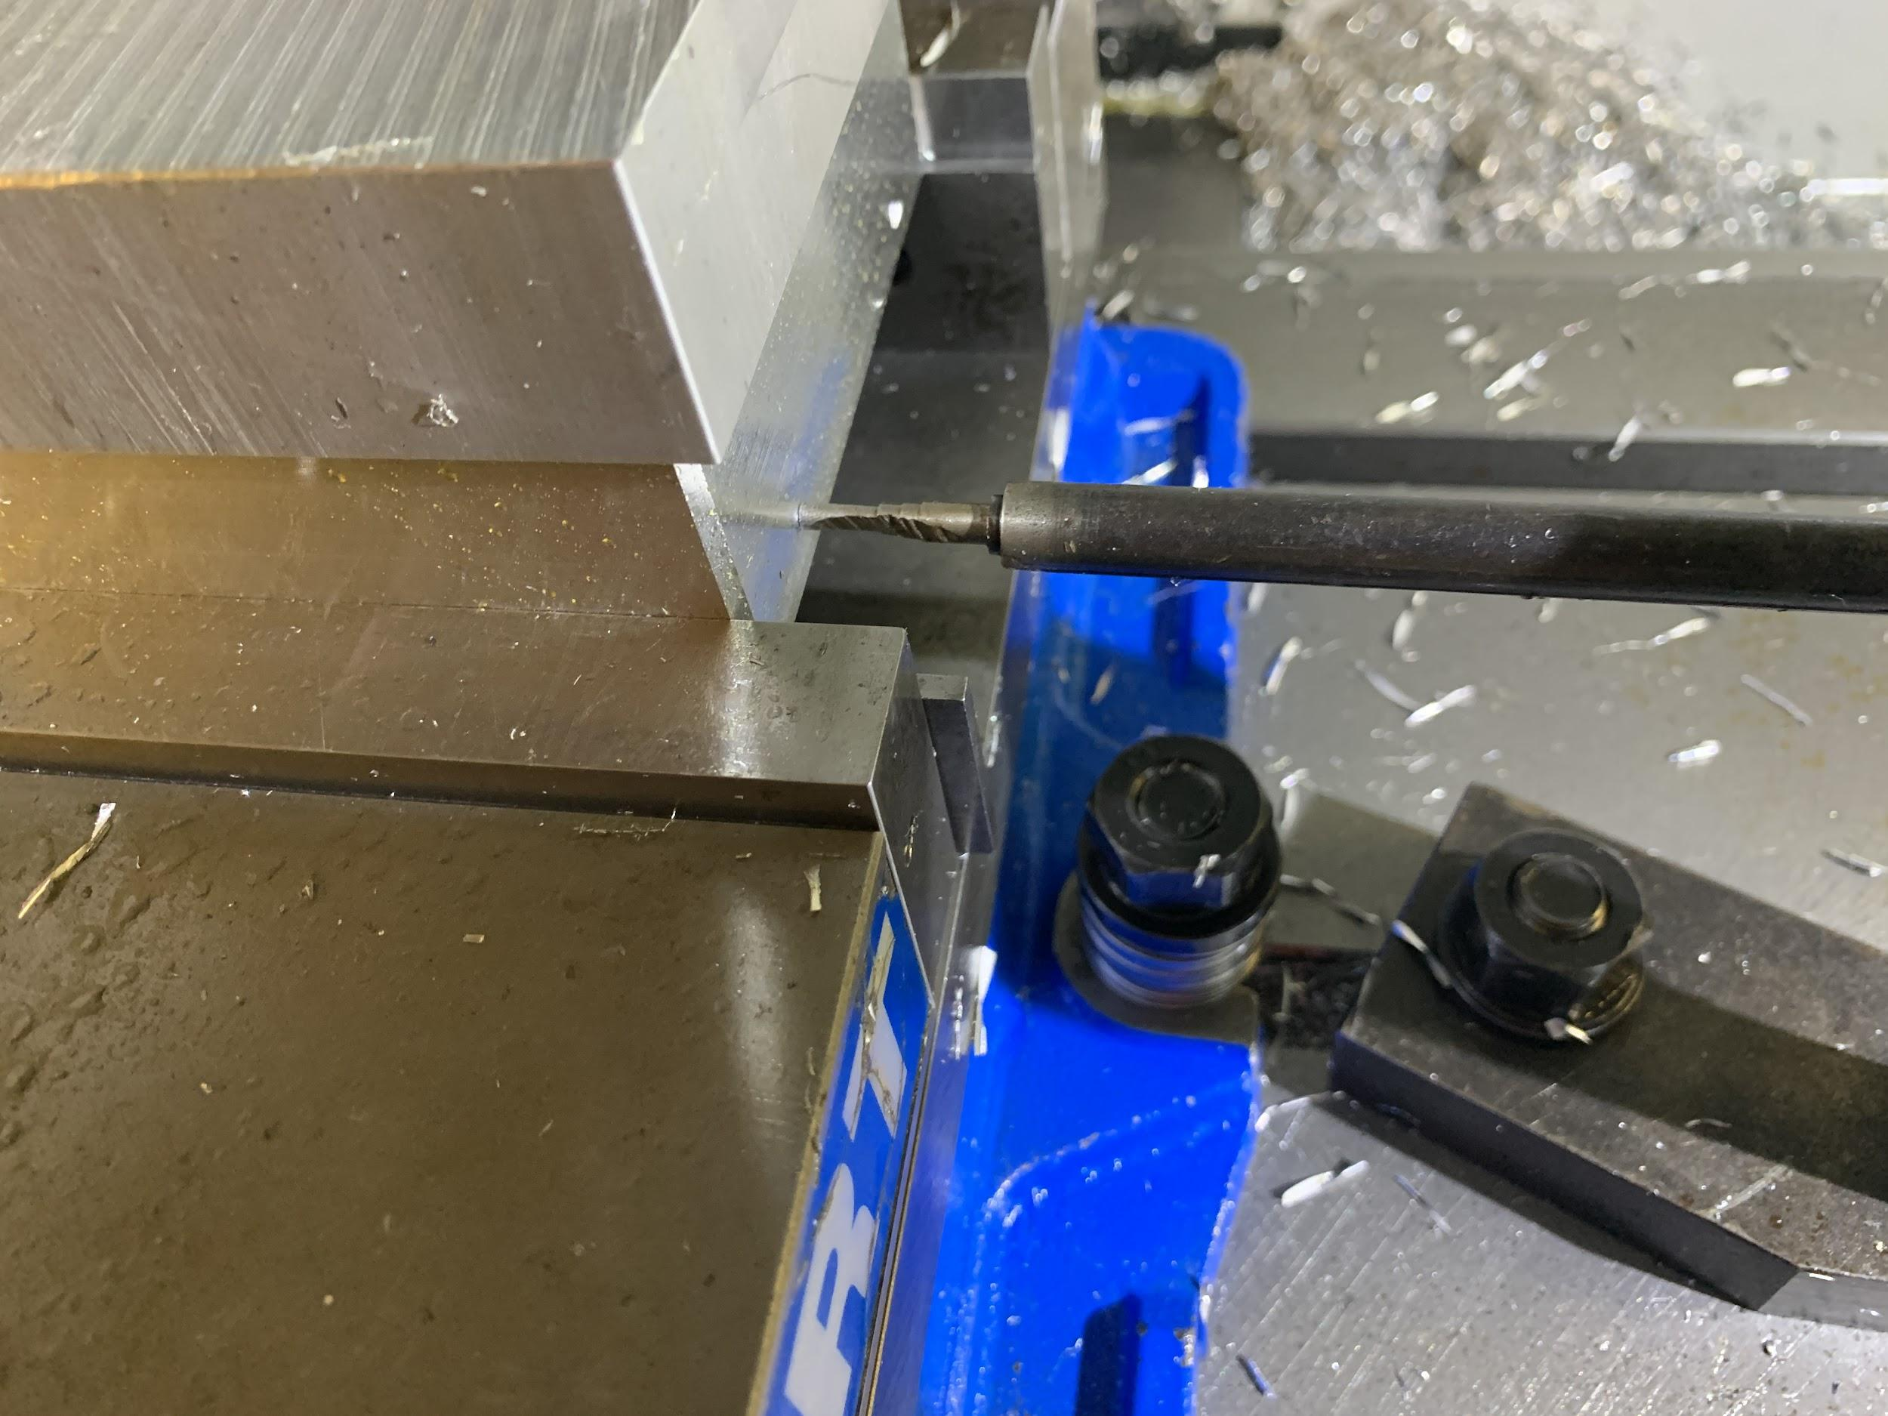

Figure 3: G55 Stopper

Tool Offsets

The way the programs are written, the z-zero plane is on the bottom of the blocks/on the top edge of the parallels. To successfully measure the tool offsets to this plane, you can do a wide variety of things. In our case we measured tool offsets to the bottom of the G54 vice and then manually adjusted them to the bottom of the parallels (which are 1.249” tall). You can also do tool offsets to the bottom of the vice, and use the Z-offset for the coordinate system to accomplish the same task (probably a little easier). [Here is a link](https://zero-divide.net/?&article_id=4768_lesson-5-everything-about-cnc-tool-length-offsets-positive-and-negaive-g43-g-code-h-offset) that explains the difference between tool offsets and positive/negative z-offsets.

Furthermore, the vices might not be the exact same height so I added a 0.0021 z-offset to G55 to compensate for the difference since the top of the parallels in each vice are slightly different. An image of our tool offsets are shown in Figure 4.

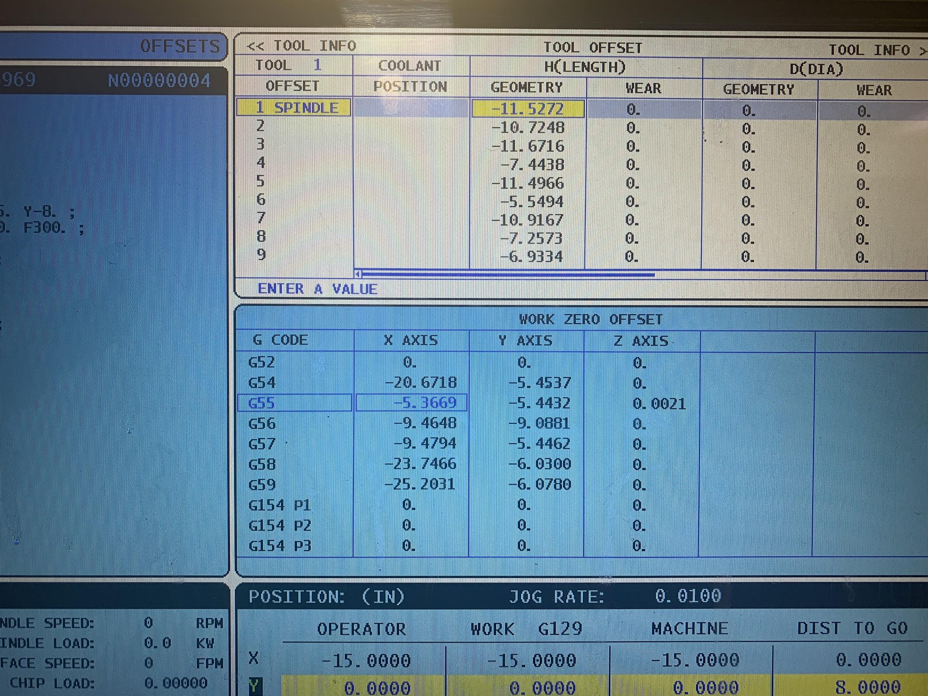

Figure 4: Tool Offset Example

Bandsawing all billets to get the blocks takes about 7 hours and you should definitely use a coarse blade (most likely not on the bandsaw normally). Both blocks take about 15 mins each to run, with the thick block being slightly shorter. Each time you run the program you get a full block (except the first time). Below is a list of tooling and supplies we used. Tools 8-10 are only used for cavity manufacturing. All of the tools should be in the blue lista cart wrapped in a rag.

Tooling used:

Two vices

Two stoppers (so the blocks end up in the same places)

4 x 1.249” parallels

Tool height setter (get a new one from beltran because all the old ones are ruined)

Tool #1 - 4.5” Face Mill

Tool #2 - 3 Flute 5/8 Carbide End Mill

Tool #3 - Center Drill

Tool #4 - 9/32 Drill

Tool #5 - 1/4 Ball Mill

Tool #6 - 7/16 Drill

Tool #7 - 7/16 EM (Find or buy a longer one because I had a lot of stick out)

Tool #8 - [1/4 Taper pin reamer](https://www.mcmaster.com/2990A53/)

Tool #9 - 1/4 Drill

Tool #10 - 1/4 Flat Carbide EM

What to improve upon for next year and general warnings:

* You need a special post processor which luckily was in the Baja archives which I have now included with the NX files
* Some system to track what teams have which blanks/need more of them (as opposed to just getting random emails and texts from people in the class).
* Better stopper system for more repeatability and accurate parts - some of them were noticeably off and it may or may not cause issues later when people start machining
* Change speeds of the drill bits because some of them squeal very loudly
* Make sure you watch the face mill do its first pass. If your blank from the bandsaw is too big then the face mill will not cut it and it will crash. After that it *should* be good to walk away from (assuming you've watched it before) however still be careful.